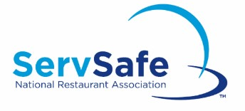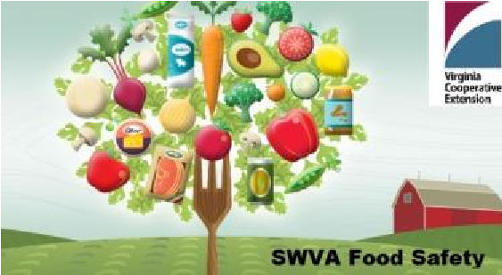

**2021 ServSafe Food Protection Manager Training & Certification Exam for Southwest VA**

*Virginia Cooperative Extension offers ServSafe Manager Certification training in a one-day format.*

This course provides a recipe for success from the industry's leading food safety training and certification program! It includes the most up-to-date FDA Food Code information incorporating the latest emerging science-based trends impacting food, industry, best practices, and requirements. More federal, state, and local jurisdictions recognize and accept ServSafe more than any other food safety training program.

**This is the training and certification exam that meets the VA Food Regulation requirement that mandates that every food service operation have someone in the facility who has supervisory responsibility to have a current Food Protection Manager certification.**

**Course cost:** $160 (Includes training, ServSafe 7th Edition book, exam scantron sheet, and exam proctor)

**Instructor:** Sandy Stoneman, SWVA Food Safety Extension Agent (sandyst@vt.edu)

**Register Now!**

* **Wytheville**: Tuesday, **January 26** (9am-6pm)
* **Hillsville**: Tuesday, **February 9** (9am-6pm)
* **Wytheville**: Tuesday, **March 23** (9am-6pm)
* **Independence**: Tuesday, **April 20** (9am-6pm)
* **Wytheville**: Tuesday, **May 25** (9am-6pm)
* **Wytheville**: Tuesday, **July 27** (9am-6pm)
* **Hillsville**: Tuesday, **August 10** (9am-6pm)
* **Wytheville**: Tuesday, **September 28** (9am-6pm)
* **Independence**: Tuesday, **October 19** (9am-6pm)
* **Wytheville**: Tuesday, **November 16** (9am-6pm)

*Wytheville: 7 Dogs Brew Pub Meeting Room– 360 W Spring St, Wytheville 24382

*Hillsville: Shoney’s Meeting Room – 2042 Carrolton Pike, Hillsville 24343

*Independence – Grayson County Extension Office/GATE Center Meeting Room – 122 Davis St, Independence 24348